Lab 0

**Exercise 1) What command would you use to extract just the counts of girls baptized?**

Arbuthnot$girls

**Exercise 2) Is there an apparent trend in the number of girls baptized over the years?  
How would you describe it?**

The trend is a positive trend, so more girls are baptized over the years as population increases over time. However, there is a big dip between 1640-1660 as shown by the graph of year vs. girls baptized. The sharp decrease in girls baptized begins in 1640 and hits a minimum around 1660, where it increases sharply until about 1665, and then increases at a normal rate. The overall trend is positive, but there are a few sharp increases and decreases over the years between 1629 and 1710.

**Exercise 3) Now, make a plot of the proportion of boys over time. What do you see? Tip: If you use the up and down arrow keys, you can scroll through your previous commands, your so-called command history. You can also access it by clicking on the history tab in the upper right panel. This will save you a lot of typing in the future.**

plot(arbuthnot$year, (arbuthnot$boys / (arbuthnot$boys + arbuthnot$girls)), type = 'l')

The graph shows that boys were always born in a higher proportion than girls between 1629-1710 from the Arbuthnot data. The graph is very volatile, but always falls into a range of .5025 to about .535 for proportion of boys.

**ON YOUR OWN**

1) 1940-2002; 3 column variables: years, boys, and girls born. There are 63 rows representing 63 years.

2) It is a similar format, but this birth data set records births over 1 million, rather than 5-7,000 in Arbuthnot.

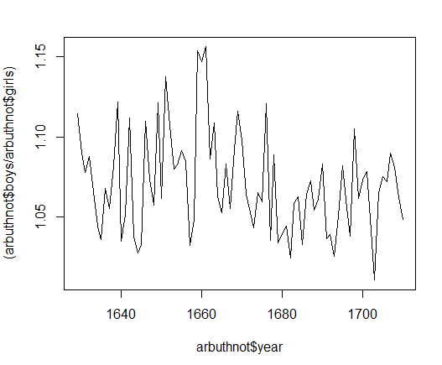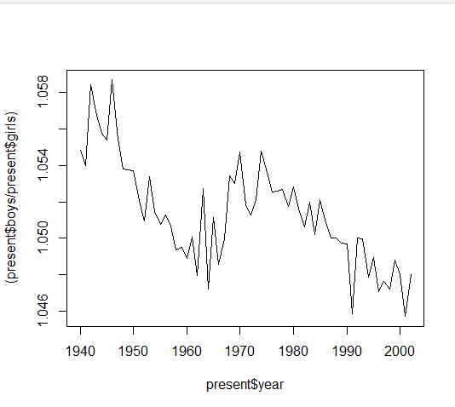3) The graph shows that the ratio of boys over girls decreases over the 63 year period, from a range of 1.058 to a minimum of 1.046. The ratio of boys to girls overall is very close to equal, but more boys are born than girls. However, the scale is very large as the numbers are over a million, so the graph shows that much more girls are being born than previous years, lowering the ratio closer to 1.0, but not that close yet. It is much less volatile than the Arbuthnot ratio, but that can be explained by the much smaller sample size. Boys are still in higher ratio than girls in both.

4) I used the max function to find the max total number of births was 4268326. The year is 1961.

which.max(present$boys + present$girls)

gives an output of 22, which is the 22nd entry which is 1961.